

Computer Networks 46 (2004) 273–293

www.elsevier.com/locate/comnet

OSPF-based hybrid approach for scalable dissemination
of QoS parameters^{q}

Turgay Korkmaz^{a,*}, Marwan Krunz^{b}, Jyothi Guntakaª
a Department of Computer Science, The University of Texas at San Antonio, San Antonio, TX 78249, USA
b Department of Electrical and Computer Engineering, University of Arizona, Tucson, AZ 85721, USA
Received 23 June 2003; received in revised form 29 February 2004; accepted 3 March 2004
Available online 26 May 2004
Responsible Editor: S. Fdida

Abstract

Current link-state routing protocols (e.g., OSPF) use ﬂooding to disseminate link-state information throughout the
network. Despite its simplicity and reliability, ﬂooding incurs unnecessary communication and processing overheads in
control plane since nodes may receive multiple copies of the same advertisement. These overheads become signiﬁcant in
protocols that support quality-of-service (QoS) routing, where links are associated with dynamic metrics (e.g., available
bandwidth) that need to be advertised frequently. The overheads can be signiﬁcantly reduced using tree-based
broadcasting approaches. Although a number of such approaches have been proposed in the literature, they have not
been used in real networks because of their complexity and/or unreliability. In this paper, we propose a hybrid link-state
dissemination approach that combines the best features of ﬂooding and tree-based broadcasting. Our approach is
particularly suited for the dissemination of ‘‘dynamic’’ link metrics (e.g., available bandwidth), which are often used in
QoS-based path selection and traﬃc engineering. In our approach, topological changes and ﬁrst-time LSAs (link-state
advertisements) are ﬂooded, whereas refresh LSAs (the ones that provide updated information on the dynamic metrics)
are sent using tree-based broadcasting. The broadcast trees in our approach are constructed dynamically during the
ﬂooding of the ﬁrst-time LSA, without the need for the complex algorithms of previously proposed tree-based ap-
proaches. Two versions of the proposed scheme are provided; one being more suitable for quasi-static topologies (i.e.,
link failure rate is low) while the other is aimed at highly dynamic networks. We show how both versions can be
integrated into the OSPF protocol. We further provide a working implementation of both versions, obtained after
modifying Moy’s OSPF source code [OSPF: Complete Implementation (with CD-ROM), Addison Wesley, Reading,
MA, 2000]. We contrast the communications and processing overheads of our scheme with those of ﬂooding and pure
tree-based broadcasting, using both analysis and simulations. Our results indicate that the hybrid approach has a
signiﬁcantly lower overhead than ﬂooding; yet it enjoys the simplicity, reliability, and fast convergence of ﬂooding.
У 2004 Elsevier B.V. All rights reserved.

q The work of M. Krunz was supported in part by the National Science Foundation through grants ANI-0095626, ANI-0313234,
and ANI-0325979; and in part by the Center for Low Power Electronics (CLPE) at the University of Arizona. CLPE is supported by
NSF (grant # EEC-9523338), the State of Arizona, and a consortium of industrial partners. An abridged version of this paper was
presented at the IEEE GLOBECOM 2002––High Speed Networks Symposium, Taipei, Taiwan, November 17–21, 2002.
* Corresponding author. Tel.: +1-210-458-7346.
E-mailaddresses: korkmaz@cs.utsa.edu (T. Korkmaz), krunz@ece.arizona.edu (M. Krunz), jguntaka@cs.utsa.edu (J. Guntaka).

1389-1286/$ - see front matter У 2004 Elsevier B.V. All rights reserved.
doi:10.1016/j.comnet.2004.03.034

274

T. Korkmaz et al. / Computer Networks 46 (2004) 273–293

Keywords: Flooding; Tree-based broadcasting; OSPF; Link-state routing; Scalable QoS routing

1. Introduction

In link-state routing, nodes in a routing domain
try to maintain an accurate ‘‘map’’ of the under-
lying network. To achieve this goal, each node
encodes the state information related to its out-
going links into a link-state advertisement (LSA)
packet and disseminates this LSA throughout the
network. To disseminate LSAs in a simple and
reliable manner, existing link-state routing proto-
cols (e.g., OSPF [18,19]) use ﬂooding, in which an
incoming LSA is forwarded to all neighbors except
the one from which the LSA was received. As a
result, a given node may receive the same LSA
several times, causing unnecessary communica-
tions and processing overhead.
One can argue that the overhead of ﬂooding
which is in control plane is small when compared
to data traﬃc. However, this is primarily the case
for static link metrics that are advertised rather
infrequently. Even in that case, routing protocols
(e.g., OSPF) try to minimize the overhead of
ﬂooding by advertising small-size LSAs every 30
min. This infrequent dissemination is suﬃcient for
a best-eﬀort service, but not for QoS-oriented
network services, in which multiple link metrics
(e.g., available bandwidth, link delay, jitter, etc.)
need to be disseminated. With more parameters
being advertised, the size of the LSA inevitably
gets larger. Moreover, some of these parameters
(e.g., available bandwidth) are quite dynamic, and
thus must be frequently disseminated (e.g., using
triggered updates [1]) to provide an accurate rep-
resentation of the underlying network. As we start
to incorporate dynamic metrics (such as the
available link bandwidth) into the routing archi-
tecture, the amount of control overhead will in-
crease by orders of magnitude, depending on the
dynamic nature of the link-state parameters. For
example an egress link that carries few connec-
tions, a change in the bandwidth of any of these
connections (including the case of connection ter-
mination) can, in principle, trigger a new band-

width advertisement. These changes can occur at
the time scale of seconds, not minutes, creating a
large number of update messages per time unit.
While QoS routing architectures are yet to be de-
ployed and more insight into and understanding of
their impact on the operation of the network are
still needed, it is our belief that such architectures
will generate large control-traﬃc volume. Note
that the large volume of control traﬃc not only
impacts the bandwidth usage, but also the eﬃ-
ciency of packet switching at the router and delay
variation for data packets. Because the router
gives higher switching priority to control packets,
the arrival of a new control packet triggers an
interrupt and forces the processor at the router to
switch from one task to another, which degrades
the performance of the router and increase the
delay for data packets. Therefore, schemes that
reduce the anticipated control-traﬃc volume will
have a great impact on the success of link-state
routing protocols.
To reduce the overhead of ﬂooding in link-state
protocols, researchers have investigated tree-based
broadcasting approaches [4,14], in which LSAs are
forwarded over broadcast trees such that every
node receives exactly one copy of each LSA. While
tree-based broadcasting reduces the overhead, it
introduces a challenging problem, namely how to
determine and maintain consistent broadcast trees
throughout the network. Previously proposed
solutions for this problem rely on complex algo-
rithms and protocols (see Section 2 for details),
making them impractical to deploy in real net-
works.
In this paper, we propose a hybrid mechanism
that combines the best features of ﬂooding and
tree-based broadcasting. The proposed mechanism
alternates between ﬂooding and tree-based
broadcasting modes. In the ﬂooding mode, ‘‘ﬁrst-
time’’ LSAs are ﬂooded to establish the broadcast
trees, over which subsequent (refresh) LSAs are
advertised in the tree-based broadcasting mode.
The proposed hybrid mechanism can, in principle,

T. Korkmaz et al. / Computer Networks 46 (2004) 273–293

275

be used with any link-state routing protocol. For
concreteness, we focus on the current OSPF pro-
tocol and its QoS extensions as described in [2].¹
In general, the proposed approach requires three
modiﬁcations to OSPF: (1) redeﬁning some of the
currently unused bits in the LSA header, (2) add-
ing a table in each router for maintaining infor-
mation relevant to the broadcast trees, and (3)
adding and/or modifying some of the steps in the
‘‘ﬂooding procedure’’ of OSPF. We implemented
and tested these modiﬁcations using the source
code and simulation environment provided by
Moy [20]. The hybrid mechanism is shown to
achieve a signiﬁcant reduction in the communica-
tions overhead compared to ﬂooding; yet, it
maintains the simplicity and reliability of ﬂooding.
Compared to pure tree-based broadcasting, the
proposed mechanism incurs a slight extra over-
head, but this overhead is overshadowed by the
simplicity of this mechanism and its amenability to
practical application in real networks. Further-
more, in contrast to previous tree-based broad-
casting mechanisms, in which the broadcast trees
are determined based on the hop count, ours uses
the minimum delay experienced during the ﬂood-
ing of a ﬁrst-time LSA to compute the broadcast

our software implementation of the hybrid
scheme, performed by modifying Moy’s OSPF
source code. A complete description of this
implementation is available online at www.cs.utsa.
edu/~korkmaz/research/hftb.

2. Background and related work

2.1. Flooding

Flooding is used in OSPF to disseminate the
link-state information to all routers in the same
domain. Each router periodically generates LSAs
representing the parameters of its outgoing links
and sends these LSAs to all of its neighbors.
Routers forward received LSAs to their neighbors
except the ones that sent the LSAs. Typically,
received LSAs are explicitly acknowledged, al-
though in some cases the acknowledgement
(ACK) is implicit (for example, if two neighbors
send the same LSA to each other at around the

32 bits

trees. As a result, it enjoys the same fast conver-
gence of ﬂooding.
The rest of this paper is organized as follows. In
Section 2, we give background information on
LS Age
Options
Link State ID
Advertising Router
LS sequence number
1

ﬂooding in OSPF and review the literature on tree-
LS checksum
length

based broadcasting. In Section 3 we present the
basic version of the proposed hybrid mechanism,
describe how to integrate it into the OSPF proto-
Router Type
0
number of advertised links l=2
Link ID
Link Data

col, analyze its overhead, and contrast this over-
Link Type | # TOS = q  number of QoS parameters
cost metric

head with those of ﬂooding and pure tree-based
broadcasting using both analysis and simulations.
In Section 4 we present a variant of the hybrid
mechanism that is suited for dynamic topologies
with a high rate of link failures. Extending the
hybrid mechanism to hierarchical OSPF networks
TOS (QoS 1)
TOS (QoS 2)

TOS (QoS q)
0
0

0
TOS metric (QoS value)
TOS metric (QoS value)

TOS metric (QoS value)
Link ID
Link Data

is described in Section 5. The paper is concluded in
Section 6. In the Appendix A, we give highlights of

1 The Opaque LSA Option [8] is another proposal to provide
Link Type | # TOS = q  number of QoS parameters
TOS (QoS 1) 0
TOS (QoS 2) 0

TOS (QoS q) 0
cost metric
TOS metric (QoS value)
TOS metric (QoS value)

TOS metric (QoS value)

QoS extensions in OSPF. Since it also relies on ﬂooding, it can
be easily integrated into our hybrid approach.
Fig. 1. Structure of an OSPF router-LSA with two advertised
links.

...
...
...
...
...
...
Header (20 bytes)
Link 2
L
ink 1

276

T. Korkmaz et al. / Computer Networks 46 (2004) 273–293

same time, then each of them can be sure that the
other has the LSA, so there is no need to gen-
erate explicit ACKs). This ﬂooding process allows
every node to acquire the same map of the net-
work.
OSPF uses ﬁve types of LSAs. For a network
with point-to-point links, only one of these types,
known as router-LSA, is used. The basic structure
of a router-LSA is shown in Fig. 1. Every router-
LSA starts with a 20-byte header that contains
information that uniquely identiﬁes the LSA. The
rest of the LSA contains the values of the ‘‘cost’’
metric and any additional QoS parameters that are
associated with the outgoing links of the LSA’s
originator. Note that OSPF currently uses a single
metric, but the type-of-service (TOS) ﬁeld in
OSPF, which has not been much used in the past,
can be redeﬁned to advertise multiple link
parameters (see [2] for details). Consider the sha-
ded ﬁelds in Fig. 1. In this example, the number of
advertised links is indicated by l. The link-state
information is then repeated l times with diﬀerent
values. Each link has some identiﬁcation infor-
mation followed by the link parameters. The
number of link parameters is indicated by q. Each
parameter is encoded using a four-byte ﬁeld that
includes the parameter name and its value. Hence,
the size (in bytes) of a router-LSA originating from
node u is given by SрuЮј^{def}20 ю 4 ю lрuЮр12 ю 4qЮ,
where lрuЮ is the number of advertised outgoing
links from node u (i.e., lрuЮ ј degрuЮ). Note that
an LSA ACK packet consists of only a 20-byte
header.
Flooding has also been used for path determi-
nation in mobile ad hoc networks (MANETs), and
reducing its overhead has been the focus of much
research. In MANETs, the routing protocol
may be proactive (table driven) or reactive (on-
demand).²Examples of proactive protocols are
DSDV [25], WRP [21], and CGSR [7]. In proactive
protocols, nodes periodically broadcast their link
(or path) costs and use Dijkstra (or Bellman–Ford)
like algorithms to compute the ‘‘shortest’’ paths to
various destinations. These protocols are some-

2 A combination of reactive and proactive approaches can
also be used, as in the zone routing protocol (ZRP) [13].

what similar to link-state and distance-vector
protocols used over the wired Internet (e.g., OSPF
and BGP). Reactive protocols, on the other hand,
operate on demand; when the source node does not
have in its cache a path to a given destination, it
broadcasts a route request (RREQ) packet, que-
rying its neighbors about the availability of such a
path. Dynamic source routing (DSR) [15], ad-hoc
on-demand distance vector (AODV) [24], and the
temporally ordered routing algorithm (TORA)
[23] are all examples of reactive routing protocols.
In their basic forms, reactive protocols rely on
ﬂooding for path discovery, whereby the source
node ﬂoods the network with its RREQ packet.
When an intermediate node receives the RREQ
packet, it responds back with a route reply
(RREP) if it has a path to the destination.
Otherwise, the intermediate node continues to
ﬂood the packet. Eventually, at least one node
(possibly the destination itself) will respond aﬃr-
matively with a RREP. The overhead of ﬂooding
via wireless broadcast is even more signiﬁcant than
ﬂooding over point-to-point links, and it can lead
to a ‘‘broadcast storm problem’’ [22] (neighboring
nodes that receive an RREQ packet rebroadcast it
simultaneously, leading to collisions, backoﬀs, re-
transmissions, etc.). Several attempts were made to
reduce the overhead of ﬂooding in reactive routing
protocols (e.g., [6,16]). For example, Ko and Va-
idya [16] proposed the location aided routing
(LAR) scheme, in which the Global Positioning
System (GPS) is used to localize path queries and
limit their propagation. A similar objective is
achieved in [6] but without the need for GPS-based
location information. Note that such techniques
are aimed at on-demand routing approaches, and
are not applicable to table-driven proactive pro-
tocols like OSPF.
The overhead of ﬂooding has also been
addressed in the context of establishing multicast
trees (e.g., [5]). In [5] the authors use consecutive
ﬂooding of a multicast request (a technique known
as expanding rings) to establish a multicast tree for
a given set of receivers. This is somewhat similar to
ﬂooding a packet with a limited time-to-live (TTL)
value, where the TTL value in incrementally in-
creased until all receivers are included in the
multicast tree.

T. Korkmaz et al. / Computer Networks 46 (2004) 273–293

277

2.2. Tree-based broadcasting

State dissemination based on tree-based
broadcasting appears in the literature in two
forms: single broadcast tree (SBT) and multiple
broadcast trees (MBT). In the SBT approach, all
nodes compute a common broadcast tree (e.g., a
spanning-tree), and every node marks its own links
on that tree. Every node then receives LSAs via
one of its marked links and forwards the LSAs
through its other marked links. The SBT approach
has two main disadvantages. First, it results in an
unbalanced load distribution since LSAs are sent
over a ﬁxed subset of the network links (i.e., the
links that belong to the broadcast tree). Second, it
is quite possible for nodes that are neighbors
according to the network graph to lie far away
from each other on the broadcast tree, a situation
that delays the convergence of the routing proto-
col. In [3] the authors explored the viability of the
SBT approach for state dissemination in the PNNI
protocol. They provided a distributed spanning-
tree algorithm for determining the broadcast tree.
However, ﬁnding this tree and maintaining it in a
consistent manner involves complex operations
such as exchanging extra control packets besides
LSAs and executing the spanning-tree algorithm in
a distributed manner.
In the MBT approach, every node has its own
broadcast tree (e.g., a shortest path tree). For
illustration, consider the trees originating from
nodes 1 and 3 in Fig. 2. The LSAs originating from
a given node are disseminated over that node’s
broadcast tree. For example, node 1 generates an
LSA and sends it to nodes 2 and 3. However, only
node 2 forwards this LSA to node 4 (according to
the broadcast tree of node 1). To disseminate
LSAs over their originators’ broadcast trees, every
node needs to know the broadcast trees of all other
nodes. This can be done as follows. Every node

determines its parent and children on every
broadcast tree and stores these parent–children
relationships in a table [14]. Fig. 3 illustrates an
example. Let T_{i}be the broadcast tree originating
from node i, i ј 1; 2; . . . ; n, where n is the number
of nodes in the network. Consider the representa-
tion of T₁at node 2. Since node 2 has only one
child on T₁(namely, node 4), it marks node 4 as its
child in the ﬁrst row of its table. So whenever node
2 receives an LSA originating from node 1, it
forwards this LSA to node 4 only. Node 2 also
stores its parent on T₁(namely, node 1) in the ﬁrst
row of its table. Since LSAs are disseminated over
diﬀerent shortest-path trees, the MBT approach
provides some form of load balancing. The con-
vergence time of this approach is also faster than
that of the SBT approach.
A key issue in the MBT approach is how to
determine the broadcast trees in a distributed
manner. Previously proposed approaches achieve
that through additional control packets (besides
the LSAs) and by relying on protocols that execute
some variant of the shortest path algorithm [4,14].
This complicates the establishment and mainte-
nance of consistent broadcast trees. The main
objective of these complicated mechanisms is to
always disseminate LSAs over the broadcast trees.
In [14] the authors addressed the issue of deter-
mining broadcast trees while the topology infor-
mation is still being disseminated over these trees.
In [4] the authors considered the idea behind re-
verse-path forwarding (RPF) in [11] and proposed
a new topology dissemination protocol called
TBRPF, in which broadcast trees are computed
based on full topological information received
over the broadcast trees themselves. In TBRPF,
every node executes Dijkstra’s algorithm to
determine a reverse minimum-hop tree, and then
exchanges some information with neighbors to
determine its parent and children from the stand-
points of other nodes. Although TBRPF provides
more reliability than other existing methods, it

1
2

3
(a)

4

1
2

3
(b)

4
suﬀers from the overhead associated with com-
puting the trees and communicating with neigh-
bors whenever a topological change occurs. The
ideas behind SBT and MBT have also been used in
various multicast protocols (e.g., CBT, DVMPR,

Fig. 2. Multiple broadcast trees originating from nodes 1 and 3.
PIM[12,17,26]). Speciﬁcally, SBT is similar to the

278

T. Korkmaz et al. / Computer Networks 46 (2004) 273–293

shared multicast trees while MBT is similar to
source-based multicast trees. In general, multicast
protocols are being designed to optimize the per-
formance for a subset of nodes (receiving nodes).
In our case, however, we try to provide better
performance in broadcasting sender’s packets to

children
1 3 4
1 n n y 1
2 y y y –
3 n n n 3
4 n n n 4

y : yes
n : no
T1
T2
T3
T4

all nodes in the network.

3. Hybrid dissemination mechanism

In this section, we ﬁrst introduce our Hybrid
Flooding and Tree-based Broadcasting (HFTB)
approach and prove its correctness. We then dis-
cuss how it can be integrated into OSPF. Finally,
children
2 3
1 y y –
2 n n 2
3 n n 3
4 n n 3

1
2

3
children
1 2 4
1 n n n 1
n n n 2
2
3 y y y –
4 y n n 4

4
children
2 3
1 n n 2
2 n n 2
3 n n 3
4 y y –

we compare the overhead of HFTB with that of
ﬂooding and pure tree-based broadcasting using
analytical and simulation results. For now, we
assume that the underlying network consists of a
single area (i.e., domain) and that no link failures
take place within the standard OSPF update
interval (30 min). In later sections, we modify
HFTB to deal with topologies that exhibit fre-
quent link failures and we also address its exten-
sion to hierarchical OSPF-based networks.

3.1. HFTB and its correctness

As indicated before, the 30 min update interval
of OSPF [18] is suﬃcient for the relatively static
cost metric, but it is not enough for other link
parameters (e.g., available bandwidth) that may
change several times within the 30 min period.
Such dynamic parameters need to be frequently
disseminated, e.g., using triggered updates. The
objective of HFTB is to disseminate triggered
LSAs using tree-based broadcasting while con-
tinue to use ﬂooding for disseminating the rela-
tively static cost metric and connectivity
information every 30 min.
Basically, HFTB is similar to previous MBT
approaches in the sense that every node maintains
the same parent–children relationships, as shown
in Fig. 3. However, in contrast to previous MBT
Fig. 3. Representing the parent–children relationships of the
broadcast trees in the MBT approach.

the update interval. No extra control packets or
complex protocols are needed to establish the
broadcast trees.
The broadcast trees are established as follows.
Let LSA_{u}denote a ﬂooded LSA that was gener-
ated by some node u. Suppose that LSA_{u}arrives at
some node i for the ﬁrst time through node j, as
shown in Fig. 4. Node i selects node j as its parent
from the standpoint of node u and acknowledges
node j. When node j receives the acknowledgment,
it records node i as its child from the standpoint of
node u. If LSA_{u}arrives at node i again via another
node v, then node i acknowledges the LSA as in
OSPF without establishing a new parent–child
relationship. After the ﬂooding of the ﬁrst LSA_{u},
every node can determine its parent and children
on the broadcast tree of node uрT_{u}Ю. In contrast to
previous approaches that establish the broadcast
trees with respect to (w.r.t.) the minimum hop
count, HFTB dynamically determines the broad-
cast trees w.r.t. the actual minimum delay, and

v

approaches, HFTB uses ﬂooding of the ﬁrst LSA
in every 30 min update interval to establish the
broadcast trees, which are then used to dissemi-
u

j
i

nate subsequent ‘‘refresh’’ LSAs generated within
Fig. 4. Establishing broadcast trees in the HFTB approach.

parent
parent
parent
parent
LSA origin
LSA origin
LSA origin
LSA origin

T. Korkmaz et al. / Computer Networks 46 (2004) 273–293

279

broadcasts LSAs over these trees, suggesting that
HFTB converges as fast as ﬂooding.

p ј hv₀ј s; v₁; . . . ; v_{k}ј ui. Without loss of gener-
ality, we assume that tЅs ј 0. So, tЅu ј

One concern here could be whether the ini-
P_{k}
iј1^{d}рv_{i}1;v_{i}Ю.

tially established optimal broadcast trees will
stay optimal for the next 30 min. It is true that
the initially optimal trees might not stay opti-
mal for the next 30 min due to delay variations
in the network. However, the delay variation on
trees can be reduced by giving priority to OSPF
packets. In fact, existing routers (e.g., Cisco
IOS) assign an IP precedence value of 6 (i.e.,
Internetwork Control) to OSPF and other con-
trol packets on the control plane, and process
them before queued data packets (see http://
www.cisco.com/warp/public/105/rtgupdates.html
for details). Giving priority to OSPF and other
control packets means that these packets will
not see the high delay variations seen on the
data paths. Therefore, from the point of view of
the refresh LSAs, the ‘‘optimal’’ path obtained
based on ﬁrst-time (ﬂooded) LSAs will likely be
stable (i.e., its delay does not change signiﬁ-
cantly) over a 30 min period.

Theorem 1 (Correctness of HFTB). Consider a
network G ј рV ; EЮ with bidirectional links. Sup-
pose that an arbitrary node s 2 V generates an LSA
and floods it throughout the network. Furthermore,
suppose that the LSA experiences some delay dрu; vЮ
while being processed and forwarded from node u to
node v. Under HFTB, T_{s}is established throughout
the network in finite time (i.e., every node can
determine its parent and children on T_{s}). Moreover,
T_{s}converges to a shortest-paths tree.

Proof. Initially, T_{s}consists of only node s. So, the
theorem is trivially true. Consider T_{s}after ﬂooding
LSA_{s}through some nodes in the network. In
ﬂooding, an arbitrary node u may receive the same
LSA_{s}several times. However, node u forwards the
incoming LSA_{s}to its neighbors only once, upon
the ﬁrst arrival of this LSA. In addition, node u
selects its parent on T_{s}by acknowledging the node
from which LSA_{s}was received for the ﬁrst time.
Subsequent arrivals of LSA_{s}at node u are
acknowledged without establishing a parent–child
relationship. Let tЅu be the time at which node u
receives LSA_{s}for the ﬁrst time along the path
To prove that T_{s}is a shortest-paths tree, we
need to show that the path p does not contain any
cycle and that p is the shortest path from s to u.
The proof follows similar arguments to those used
in [10, pp. 523–525] for shortest-paths trees.
However, instead of the process of relaxing a link
рu; vЮ in [10], we consider the process of forwarding
ﬁrst-time LSA_{s}from node u to node v. So it is
suﬃcient to show that forwarding LSA_{s}from node
u to node v upon its ﬁrst arrival is the same as
relaxing the link рu; vЮ in the computation of a
shortest-paths tree.
In computing the shortest-paths tree, a node u
with minimum tЅu is selected and every link рu; vЮ
is considered for relaxation in a sequential manner.
If tЅu ю dрu; vЮ < tЅv , then link рu; vЮ is relaxed,
i.e., the parent of node v is set to node u and tЅv is
set to tЅu ю dрu; vЮ. In HFTB, paths are explored
in parallel. So node u starts forwarding LSA_{s}
through рu; vЮ as soon as it receives LSA_{s}for the
ﬁrst time. In other words, a node u with minimum
tЅu is automatically selected in parallel and every
link рu; vЮ is considered. If node v receives LSA_{s}for
the ﬁrst time via node u, then the parent of node v
is set to node u and tЅv is set to tЅu ю dрu; vЮ; this is
the same as relaxing рu; vЮ in [10]. Otherwise, no
parent–children relationship is established again.
The rest of the proof follows the same proofs in
[10, pp. 523–525].
Finally, forming the broadcast tree T_{s}takes ﬁ-
nite time since in ﬂooding every node receives
LSA_{s}in a ﬁnite amount of time. h

3.2. Integrating HFTB into OSPF

OSPF can be easily modiﬁed to support the
proposed approach, as outlined in Fig. 5. In gen-
eral, we make three modiﬁcations to OSPF. The
ﬁrst one is to designate one of the unused bits of
the Options ﬁeld in the LSA header as Flooding or
Tree-based broadcasting (FT)-bit. If the FT-bit is
set to 0, the LSA will be ﬂooded throughout the
network as in the standard OSPF and will be used
to establish the broadcast tree of that LSA. If this
bit is set to 1, then the LSA will be disseminated

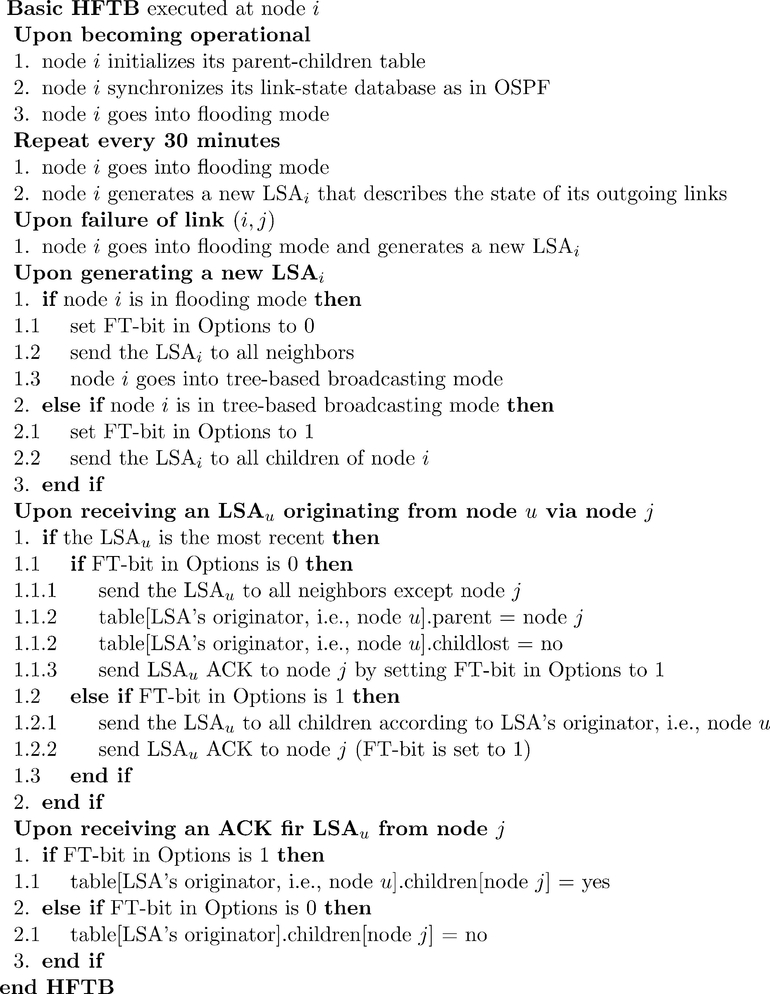

280

T. Korkmaz et al. / Computer Networks 46 (2004) 273–293

Fig. 5. Integrating HFTB into the OSPF protocol.

over its originator’s broadcast tree. The FT-bit is
also used in LSA ACKs. In this case, if the FT-bit
is 1, then this is an indication that the receiver has
selected the sender as its parent; otherwise, the
receiver has a diﬀerent parent. When a sender node
receives an ACK with FT-bit ј 1, this sender re-
cords the receiver as its child. To maintain these
parent–children relationships, we need to create a
table at each node, which is the second required
modiﬁcation. The third modiﬁcation is to add/
change some steps in the ﬂooding procedure of

OSPF (as listed in Fig. 5), so that the broadcast
trees can be established during the ﬂooding of the
ﬁrst LSAs and used during the tree-based dis-
semination of the subsequent LSAs generated
within the 30 min interval.
We implemented HFTB, starting with the
OSPF’s source code provided in [20] and modify-
ing this code to account for the above required
changes. The implementation was tested on a
‘‘real’’ network of four Linux-based PCs acting as
OSPF nodes. It was also tested using the simula-

T. Korkmaz et al. / Computer Networks 46 (2004) 273–293

281

tion tool provided in [20]. The details of our
modiﬁcations and implementations are summa-
rized in Appendix A and described in detail in a
technical report that is available online at
www.cs.utsa.edu/~korkmaz/research/hftb.

3.3. Performance comparisons

To compare the overheads of various dissemi-
nation mechanisms, we consider two performance

is 20 bytes while the size of an LSA packet
originating from node u is S рuЮ ј 20 ю 4 ю
lрuЮр12 ю 4qЮ bytes, where lрuЮ is the number of
advertised links (i.e., the degree of node u) and q is
the number of parameters associated with every
link. If no link failure occurs in a given 30 min
interval, the TNLA and TSLA of ﬂooding are
TNLAflooding^{ј}2рk ю 1Юnm; р1Ю
Xn

measures: (1) the total number of LSAs and ACKs
(TNLA), which gives an indication of the pro-
TSLAflooding^{ј р}k ю 1Ю

uј1
mЅSрuЮ ю 20 :
р2Ю

cessing overhead, and (2) the total size (in bytes) of
the exchanged LSAs and ACKs (TSLA), which
gives an indication of the communications over-
head. These measures can be determined analyti-
cally under some ideal link conditions, namely, no
LSA losses, no retransmissions, and no implicit
ACKs. We ﬁrst present such results for ﬂooding,
HFTB, and pure tree-based broadcasting. We then
compare these results with the ones obtained via
simulations, using the tool provided in [20]. Note
that our analytical results are intended to provide
lower bounds on the TNLA and the TSLA. We
simply use the analytical results (the lower bounds
on the TNLA and the TSLA) to illustrate the
impacts of diﬀerent system parameters on the
performance of the existing and proposed solu-
tions, and compare the general performance trends
in these solutions. In other words, our analytical
results are not intended to replace the simulation
results, which take into account the dynamic
behavior of the system at hand. In our emulations/
simulations, we relax the simplifying assumptions
made for analytical results and measure the TNLA
and TSLA of the exiting and proposed schemes
under the actual operation of OPSF.

3.3.1. Analytical results
Consider a network with n nodes and m links.
In the above equations, we assume that every LSA
is explicitly acknowledged. So when two neigh-
boring nodes, say u and v, receive the same LSA
from a third node, one of them, say u, forwards it
ﬁrst to the other, which in turn acknowledges the
LSA. As a result, the total number of forwarded
LSAs in the network will be the same as the total
number of ACKs (i.e., half of the analytically
computed TNLA are LSAs). In a real network,
however, u and v may forward the same LSA to
each other around the same time. In this case, each
of them can be sure that the other has the LSA,
and there is no need to generate an explicit ACK.
Compared to the scenario assumed in the analysis,
there is one additional generated LSA but one less
ACK, which means that the actual TNLA value is
roughly equal to the analytically computed one
(the latter is slightly smaller because the analysis
ignores retransmissions of LSAs). As for the
TSLA measure, its actual value will be much larger
than the analytically predicted one, because there
are more LSAs than ACKs in the actual TNLA
value.
In pure tree-based broadcasting, LSAs are dis-
seminated over trees, each consisting of n 1
links. Thus, the TNLA and TSLA of tree-based
broadcasting are

Each node u periodically (every 30 min) generates
a router-LSA and ﬂoods it as in the standard
OSPF. Within the 30 min period, each node may
be triggered to generate additional router-LSAs
that advertise the most recent values of the link-
TNLAtree^{ј}2рk ю 1Юnрn 1Ю;
Xn
TSLAtree^{ј р}k ю 1Ю рn 1ЮЅSрuЮ ю 20 :
uј1
р3Ю

р4Ю

state parameters. Let k indicate the average num-
ber of triggered advertisements within a 30 min
interval. Recall that the size of an ACK packet
Note that establishing the broadcast trees also
involves some protocol overhead, which we are
ignoring since our focus is on the TNLA and

282

T. Korkmaz et al. / Computer Networks 46 (2004) 273–293

TSLA during the state dissemination phase. Also
note that there are no implicit ACKs in pure tree-
based broadcasting.
For HFTB, no extra protocol overhead is in-
curred due to the establishment of broadcast trees
during the ﬂooding of the ﬁrst LSA. The TNLA
and TSLA of HFTB are
TNLAHFTB^{ј}2рnm ю knрn 1ЮЮ; р5Ю
Xn

processing overhead) of compared schemes in-
creases linearly. However, the TNLA of ﬂooding
increases at a higher rate than the other two
schemes. Fig. 7 depicts the TSLA of various dis-
semination mechanisms versus m, q, and k. As m
increases, the TSLA (and thus the communica-
tions overhead) of ﬂooding increases quadrati-
cally, while this increase is linear in other
mechanisms. As shown in the ﬁgure, the TSLA of
all mechanisms increases linearly with q. However,

TSLAHFTB^{ј}

uј1
mЅSрuЮ ю 20
the TSLA of ﬂooding increases at a higher rate
than those of tree-based mechanisms. The TSLA

ю k^{X}n
uј1
рn 1Ю:ЅSрuЮ ю 20 :
р6Ю
of all mechanisms is linearly proportional to k.
Once again, the TSLA of ﬂooding increases at a
much higher rate than that of other mechanisms.

In practice, some ﬁrst-time LSAs will be implicitly
acknowledged during the ﬂooding phase (but not
during the tree-based broadcasting phase). So the
relative improvement of HFTB over ﬂooding will
be more pronounced in practice than what is being
predicted by the above equations (as shown later
in simulations).
The TNLA depends on three parameters
рn; m; kЮ while the TSLA depends on four param-
eters рn; m; q; kЮ. In the numerical examples below,
we consider topologies with n ј 100, and we vary
m, q, and k. The same trends have been observed
for other values of n. Fig. 6 depicts the TNLA of
various dissemination mechanisms versus m and k.
As m and k increase, the TNLA (and thus the
In general, pure tree-based broadcasting is ex-
pected to provide the best possible eﬃciency in
state dissemination, given that the broadcast trees
are already established. However, establishing such
trees in the pure tree-based approach requires
complex algorithms and protocols to maintain
consistent trees throughout the network. Because
of the complexities and/or unreliabilities of previ-
ous tree-based mechanisms, current Internet pro-
tocols do not use tree-based broadcasting, and
instead rely on ﬂooding despite its high communi-
cations overhead. The proposed HFTB mechanism
takes advantage of both ﬂooding and tree-based
broadcasting. HFTB is easy to incorporate into
the current link-state protocols and provides

14

x 10⁵

Flooding

n=100, q=4, and λ=6

9

8

x 10⁵

Flooding
HFTB

n=100, m=400, and q=4

12

10

8

6

4

2

0
HFTB
Tree-based Broadcasting
7

6

5

4

3

2

1

0
Tree-based Broadcasting

100 200 300 400 500 600 700 800 900 1000
m
2
4
6
λ
8
10

Fig. 6. TNLA (processing overhead) versus m and k (based on analysis).

TNLA within 30-minute interval
TNLA within 30-minute interval

T. Korkmaz et al. / Computer Networks 46 (2004) 273–293

283

8
4.5 x 10
4

Flooding
HFTB

n=100, q=4, and λ=6

7
9 x 10
8

Flooding
HFTB

n=100, m=400, and λ=6

7
12 x 10

Flooding
HFTB

n=100, m=400, and q=4

3.5
3
2.5
2
1.5
1
0.5
0
Tree-based Broadcasting
7
6
5
4
3
2
1
Tree-based Broadcasting
10
8
6

4
2

0
Tree-based Broadcasting

100 200 300 400 500 600 700 800 900 1000
m
1
2
3
q
4
5
2
4
6
λ
8
10

Fig. 7. TSLA (communications overhead) versus m, q, and k (based on analysis).

signiﬁcantly better performance than ﬂooding. It is
particularly advantageous in networks that sup-
port QoS routing, where the values of q and k are
typically larger than those of best-eﬀort networks.

3.3.2. Simulation results
We also compare the performance of our
implementation of HFTB against ﬂooding using
the simulation tool ospfd_sim provided in [20].
This tool takes an entire OSPF network as a con-
ﬁguration ﬁle and executes a copy of the actual
ospfd software for each router, allowing us to
test/evaluate actual implementations (and modiﬁ-
cations) of the OSPF protocol as if we had real
OSPF routers. In our simulations, we use the
topologies shown in Fig. 8, which are modiﬁed
versions of the ANSNET topology [9]. The con-
ﬁguration ﬁles for these topologies are available
online at www.cs.utsa.edu/~korkmaz/research/
hftb. Since the general trends in TNLA and TSLA
as functions of k and q are clear, we just select one
reasonable value for k and q. For example, we as-

21
10 18 22

23

sume that each link is associated with three QoS
parameters (i.e., q ј 3) whose values are refreshed
ﬁve times within each 30 min period (i.e., k ј 5). A
smaller value would not show clearly the diﬀerence
between HFTB and ﬂooding. On the other hand, a
larger value would require more simulation time
and resources, without necessarily depicting a dif-
ferent trend in the behavior. For each topology, the
simulation program was ran for three hours. The
obtained TNLA and TSLA values, normalized and
averaged over a 30 min interval, are shown in Fig.
9. The ﬁgure also shows the TNLA and TSLA
values computed using the previous formulas. For
the TNLA, the analysis and the simulations pro-
duce comparable results, with the diﬀerence
attributed to the random initialization of nodes in
the simulations and the enabling of LSA retrans-
mission. In the case of the TSLA, the diﬀerence
between the analysis and the simulations is signif-
icant, particularly for ﬂooding. The cause of this
big gap is mainly attributed to the assumption used
in the analysis that all LSAs are sent in one

21
23
10 18

4

3
1

5

2

6

7

9

8

13

17
11

14

16

12

15
19

20

31

26

32

28
24

27

29

30

25

4

3
1

5

2

6

7

9

8

13

17

16
11

14

12

15
19

31

20

26

28

32
24 22

27

29

30

25

Fig. 8. Modiﬁed 32-node ANSNET topologies with 54 and 91 links.

TSLA within 30-minute interval
TSLA within 30-minute interval
TSLA within 30-minute interval

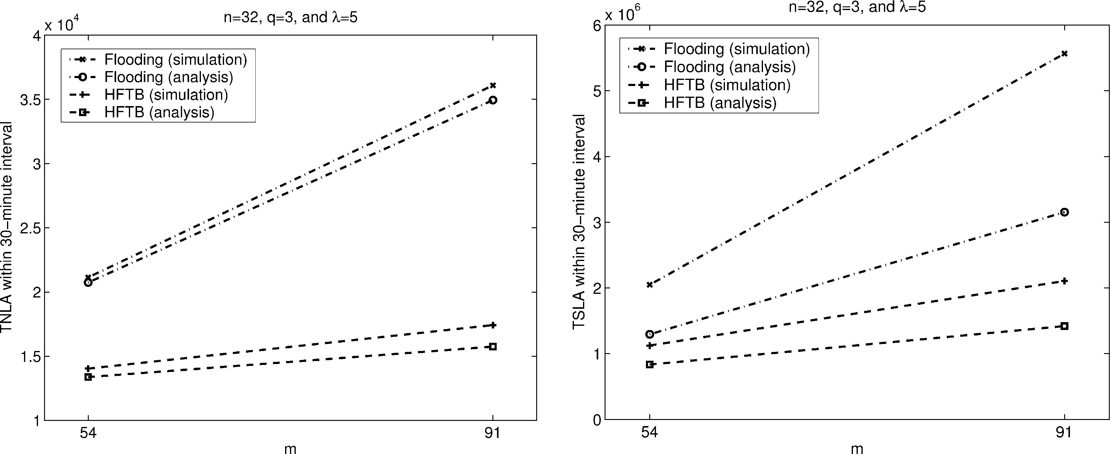

284

T. Korkmaz et al. / Computer Networks 46 (2004) 273–293

Fig. 9. TNLA and TSLA versus m for ﬂooding and HFTB (based on analysis and simulation).

direction over a link and explicitly acknowledged in
the other direction. In the simulations, however,
several LSAs are sent in both directions over a link
and implicitly acknowledged, resulting in more
LSAs than ACKs. For example, in one simulation
run on the network with 54 links, we counted
14,994 LSAs and 6148 ACKs in the case of ﬂood-
ing. Their total (21,142) is the TNLA value, which
is close to its analytically obtained counterpart
(20,736). In summary, the number of implicit
ACKs (and thus the number of LSAs) increases
during actual ﬂooding, resulting in signiﬁcantly
higher TSLA than what is analytically expected. In
case of HFTB, some implicit ACKs are used during
the ﬂooding of the ﬁrst-time LSAs. However, since
subsequent LSAs are disseminated over the
broadcast trees, implicit ACKs are no longer used,
resulting in only a slightly higher TSLA than what
is analytically expected. Accordingly, we should
expect that in practice, HFTB will provide a much
better performance gain over ﬂooding than what is
analytically predicted.

4. Enhanced hybrid mechanism

The previously discussed HFTB mechanism
computes the broadcast trees once every 30 min.

However, due to topological changes, particularly
link failures, some broadcast trees may become
disconnected shortly after they have been updated.
If no action is taken to repair these trees, some
nodes may not receive the up-to-date values of link
parameters for at most 30 min. The basic HFTB is
still a viable solution if the probability of a link
failure is low or if the underlying path selection
algorithm is capable of dealing with inaccurate
state information. However, if highly accurate
state information is needed at every node, then the
disconnected trees should be repaired during the
tree-based broadcasting phase. This can be done
by using a slightly modiﬁed version of HFTB,
which we refer to as HFTB with repair tree option
(HFTB-RT).
In the absence of link failures, HFTB-RT is
similar to the basic HFTB. When a link fails,
HFTB-RT dynamically repairs the disconnected
broadcast tree(s) by switching the LSA of that tree
to the ﬂooding mode at the disconnection point.
This is similar to the node at disconnection point
instantiating the LSA. As an example, consider the
situation in Fig. 4. Suppose that link рj; iЮ has gone
down, disconnecting T_{u}. Upon detecting the link
failure, node j realizes that it has lost its child i
from the standpoint of node u while node i has lost
its parent. Now assume that node j receives an

T. Korkmaz et al. / Computer Networks 46 (2004) 273–293

285

LSA from node u in tree-based broadcasting
mode. In this case, since node j knows that node i
and other successors will not receive LSA_{u}from
any other nodes, it will ﬂood LSA_{u}throughout the
network to make sure every node gets the same
LSA. Although the LSA is ﬂooded with the same
sequence number, we mark some bits in the header
to indicate that this LSA is more recent than the
previous ones so that the nodes that already have
it will not discard it. For example, as shown by the
dashed arrows in Fig. 10, node u receives LSA_{u}
ﬂooded back from j. However, node u does not
discard it, since the RT-bit that we describe later in
this LSA is set to 1. So node u updates its database
and further ﬂoods this LSA to other neighbors. At
some point during this ﬂooding, node v receives
the LSA and forwards it to node i. Note that in
general it is possible that LSA_{u}might reach node i
through a node other than node u or v. In any case,
the node from which node i receives the LSA_{u}ﬁrst
time is selected as the new parent of node i on T_{u}.
Accordingly, node i sends an ACK message to that
node (e.g., v), indicating the establishment of a
new parent–child relationship. When node v re-
ceives this ACK, it records node i as a child. Note
that the objective here is to repair the tree rather
than establishing it from scratch. So if a node re-
ceives the same LSA from its child, then this node
should not select its child as its parent. For
example, in Fig. 10, node u gets the LSA back
from node j, but does not select it as a parent. As a
result, the broadcast tree originating from node u
is repaired, as shown by the solid arrows in Fig. 10.
Also note that the same LSA is sent over some
links twice, increasing the TNLA and TSLA.
However, our simulations indicate that HFTB-RT
still gives much better performance than ﬂooding.
Integrating HFTB-RT into OSPF can be done
as described in the pseudo-code in Fig. 11. In

v
u i
j

Fig. 10. Repairing broadcast trees in HFTB-RT.

addition to the OSPF modiﬁcations described in
Section 3.2, we need to make two other changes.
First, we need to designate a second unused bit in
the Options ﬁeld of the LSA header as the Repair
Tree (RT) bit. Following a link failure, nodes at
both ends of the failed link generate new LSAs
with RT-bit ј 1 and ﬂood these LSAs throughout
the network. These LSAs will be used to repair the
broadcast trees. Suppose that some node i receives
LSA_{u}with FT-bit ј 0 and RT-bit ј 1 via some
node v. Node i ﬁrst checks whether it has a parent
on T_{u}. If not, it selects node v as its parent and
sends an ACK message with FT-bit ј 1 and RT-
bit ј 0 to node v. Upon receiving this ACK, node v
records node i as its child.
The second change is to add a new step in the
ﬂooding procedure of OSPF, as follows. If the link
connecting node i to one of its children on the tree
of node u goes down, then node i should switch an
incoming LSA of node u from tree-based broad-
casting mode to ﬂooding mode (i.e., change the
FT-bit and the RT-bit from 1 and 0 to 0 and 1,
respectively). Node i then ﬂoods that LSA to all
neighbors including its own parent. During this
ﬂooding, those nodes that have lost their parents
due to the link failure can select a new parent,
repairing the disconnected trees. Again by modi-
fying the OSPF’s source code provided in [20], we
have implemented HFTB-RT and tested our
implementation using both a real network with
four OSPF nodes and also using the simulation
tool in [20].
When no link failures take place, HFTB-RT
and HFTB have the same TNLA and TSLA per-
formance. Under link failures, HFTB-RT uses the
ﬂooding mode more often than HFTB, and its
TNLA and TSLA values increase with the fre-
quency of failures. Analytical estimation of these
values is not possible at present, since it requires
knowledge of the number of trees that become
disconnected following a link failure. Instead, we
use simulation results to compare ﬂooding and
HFTB-RT. Again we use the ANSNET topologies
and we let q ј 3 and k ј 5. The simulations are
ran for three hours with various numbers of link
failures happening at diﬀerent times within the
three hours. The TNLA and TSLA values aver-
aged over a 30 min interval are shown in Fig. 12

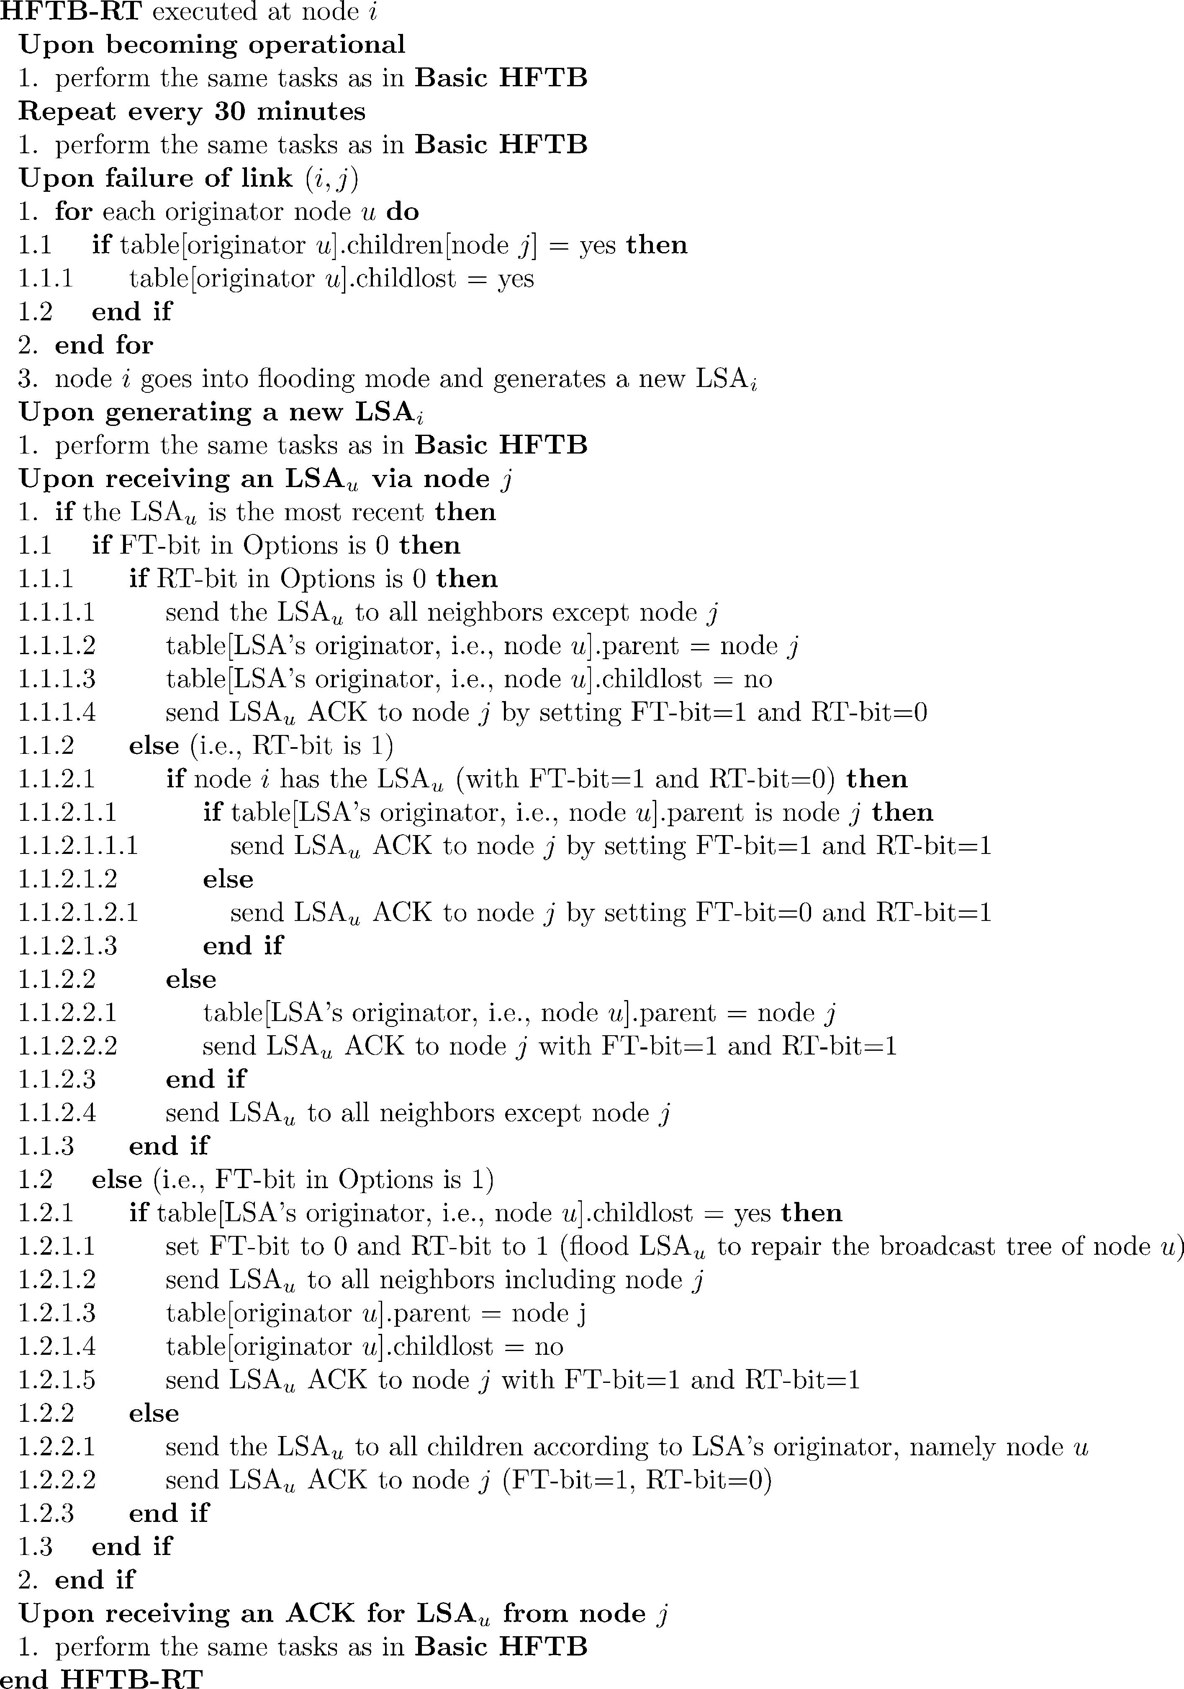

286

T. Korkmaz et al. / Computer Networks 46 (2004) 273–293

Fig. 11. Integrating HFTB-RT into the OSPF protocol.

for the 54-link topology (similar trends were also
observed for the 91-link topology).
As the number of link failures increases, the
TNLA and TSLA of ﬂooding decrease while those

of HFTB-RT increase gradually. The reason for
this is that, since the number of active links in the
network decrease due to link failures, the ﬂooding
sends LSAs through less number of links and thus

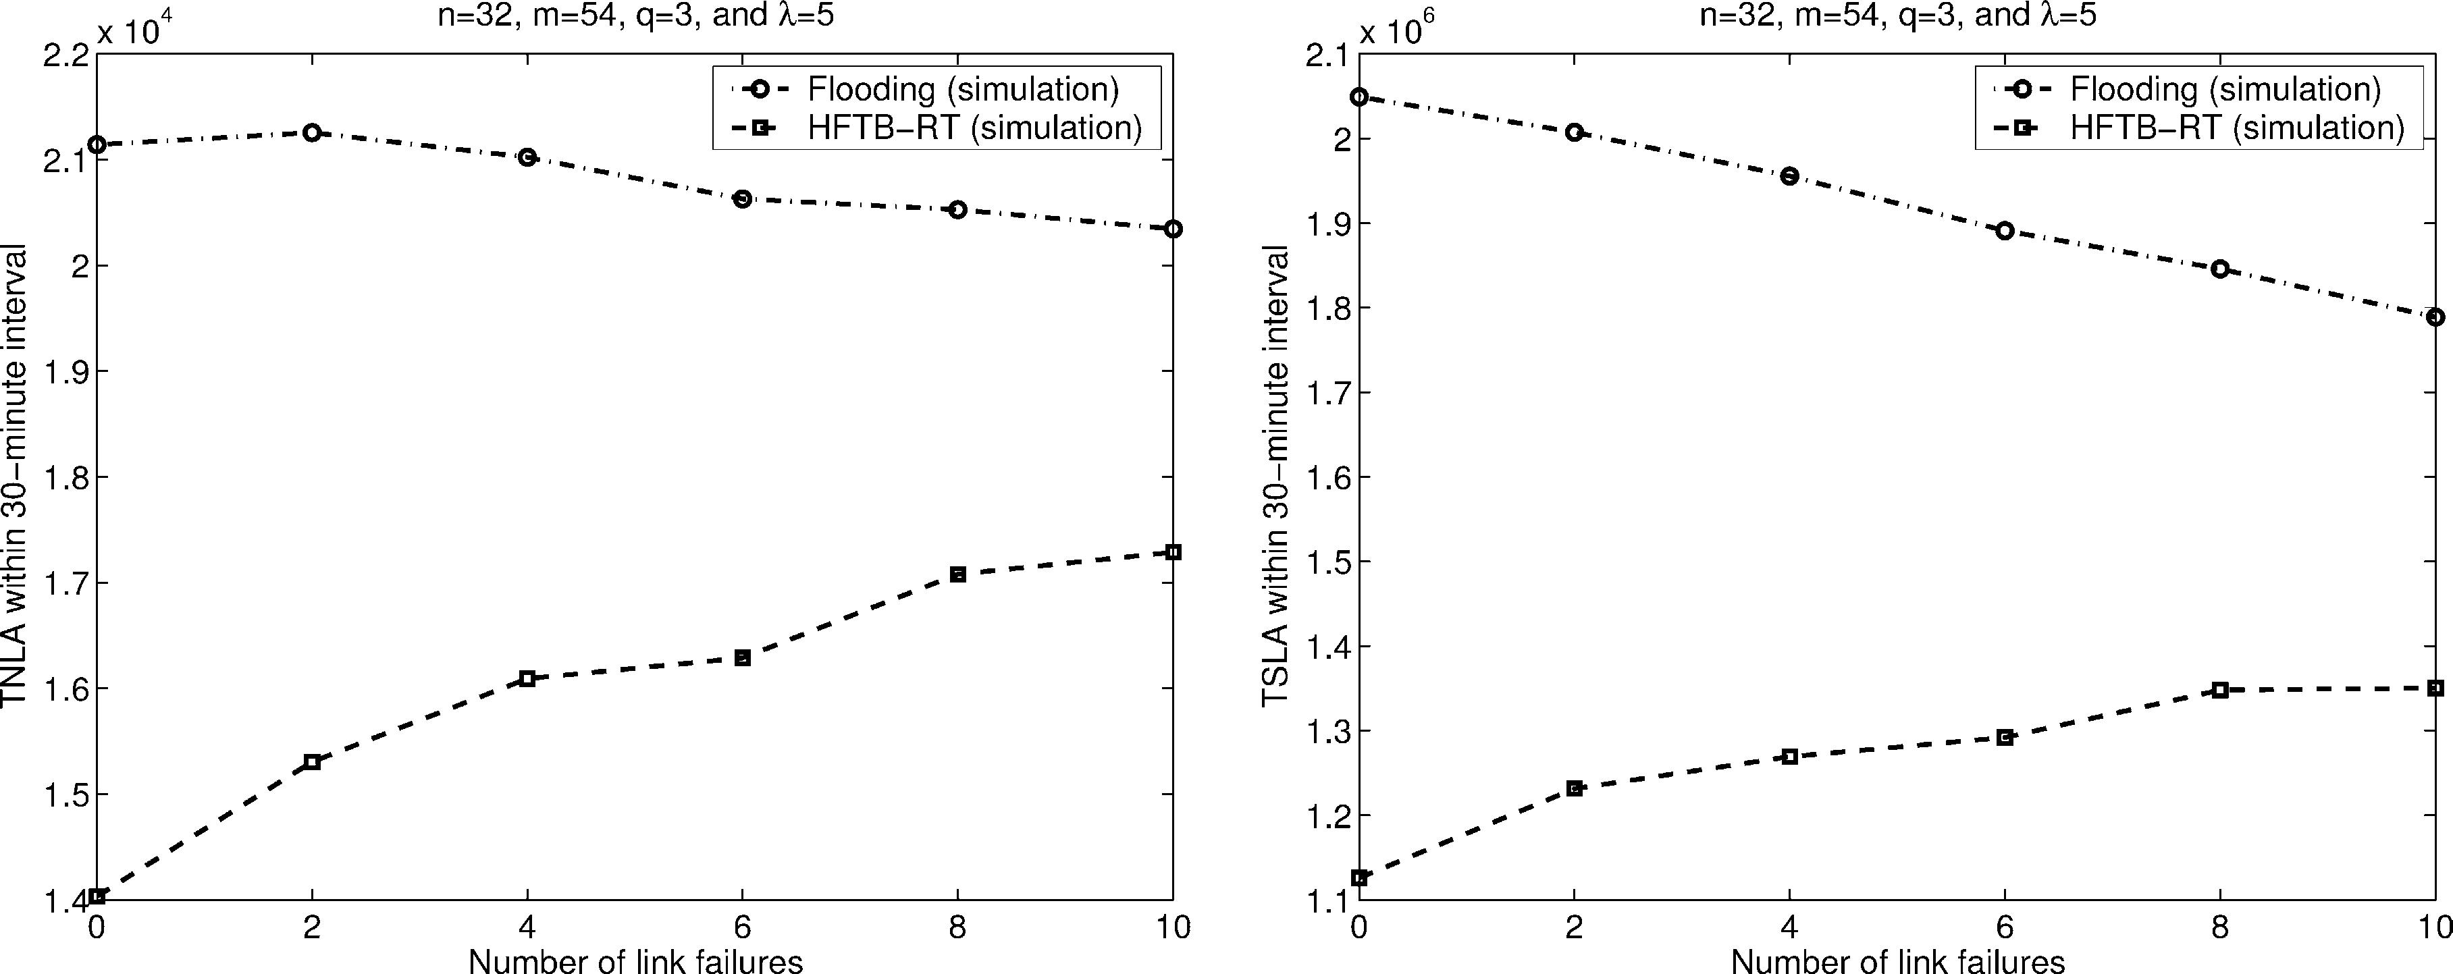

T. Korkmaz et al. / Computer Networks 46 (2004) 273–293

Fig. 12. Overhead of HFTB and ﬂooding versus the number of link failures (simulations).

287

reduce the TNLA and TSLA. In HFTB-RT,
however, since some LSAs in tree-based broad-
casting mode are switched to ﬂooding mode in
case of link failures and ﬂooded throughout the
network, the TNLA and TSLA of HFTB-RT in-
crease gradually with the increase of link failures.
However, HFTB-RT is still giving better perfor-
mance than the ﬂooding under moderate number
of link failures. Note that as the number of link
failures increases, the network becomes more
sparse (i.e., looks like a tree). In this case, ﬂooding
may perform better than HFTB-RT. In practice,
however, core networks do not experience frequent
link failures that lead to sparse topologies.
Therefore, HFTB-RT is a viable solution for dis-
seminating QoS-related state information accu-
rately and eﬃciently in practice.

5. Extending HFTB(-RT) to OSPF-based hierar-
chical networks

For scalability reasons, OSPF supports two-
level hierarchical routing, in which the network is
divided into areas. In each area, the area border
routers capture the routing information within that
area, summarize this information into summary-
LSAs, and then ﬂood these LSAs throughout the
other areas and their border routers. So far, we
have explained the operation of HFTB and

HFTB-RT within an area. We now explain how to
use/extend the proposed hybrid approach to hier-
archical OSPF networks. First, note that it is
possible to use HFTB(-RT) within areas while still
using ﬂooding between areas. This may be par-
ticularly appropriate when the number of areas is
small or when the inter-area connectivity is sparse.
Basically, since OSPF also uses ﬂooding be-
tween areas (but involving diﬀerent types of
LSAs), a similar approach to the one used within
an area can be used here. We need to compute and
maintain broadcast trees for the upper layer of the
hierarchy, and to make the HFTB-related modi-
ﬁcations (FT-bit in the router LSAs) to the other
types of LSAs (e.g., summary LSAs) that are ex-
changed between areas. The rest is similar to what
was described before. In other words, an area
border router will ﬂood the ﬁrst summary LSA
within the 30 min interval so that each node can
establish the broadcast trees for upper layer areas.
After the ﬂooding of the ﬁrst summary LSA, all
the nodes within the network would use the
broadcast trees to disseminate the subsequent
summary LSAs throughout the network. Note
that the broadcast trees established in for upper
layer would be consistent with the ones created
within the area because intra-area routing has
precedence over inter-area routing. We are cur-
rently in the process of making these modiﬁcations
to the source code of the OSPF.

288

T. Korkmaz et al. / Computer Networks 46 (2004) 273–293

6. Conclusions and future work

We provided a hybrid state dissemination
mechanism that combines ﬂooding and tree-based
broadcasting (HFTB) to achieve simple yet reliable
and eﬃcient link-state dissemination. Such a
mechanism is particularly needed in the context of
QoS routing, which involves frequent dissemina-
tion of several dynamic parameters. In contrast to
previous tree-based broadcasting approaches,
which require complex algorithms and protocols to
determine and maintain the broadcast trees, the
proposed HFTB simply determines the broadcast
trees by ﬂooding ﬁrst-time LSAs. Subsequent LSAs
that update the QoS-related state of an existing
link(s) are then disseminated over the broadcast
trees. To deal with link-failures, we provided a
modiﬁed version of HFTB, called HFTB-RT that
can repair disconnected trees. We described how to
integrate the proposed hybrid mechanisms into
OSPF. For this purpose, two of the currently un-
used bits of the Options ﬁeld in the LSA header are
deﬁned as FT-bit and RT-bit. Using these bits, we
slightly modiﬁed the ﬂooding procedure of OSPF
to determine the broadcast trees and to disseminate
LSAs over these trees. Accordingly, we imple-
mented HFTB and HFTB-RT by modifying the
existing source code of OSPF. We compared the
proposed mechanisms with the ﬂooding using
numerical and simulation results. If there are no
link failures, HFTB-RT has the same performance
of HFTB. Otherwise, it incurs some extra overhead
over HFTB. However, by using HFTB-RT, nodes
dynamically repair disconnected broadcast trees in
the case of link failures and acquire the most recent
LSAs in a simple and eﬃcient manner. In spite of
this overhead, the HFTB-RT provides signiﬁcantly
better performance than currently used ﬂood-
ing while maintaining the simplicity and reliabil-
ity of ﬂooding under reasonable number of link
failures. Moreover, in simulation we observed that,
the ﬂooding procedure of OSPF sends the same
LSAs over some links on both directions and
counts them as implicit ACKs. Since this results in
having more LSAs than ACKs in the network, the
TSLA of the ﬂooding excessively increases in
practice. However, the proposed tree-based hybrid
approach avoids implicit ACKs and thus provides

much better TSLA performance than the ﬂooding
in practice.
As a future work, we plan to implement the
proposed hybrid mechanism under the hierarchical
structure of OSPF while investigating how to
further simplify it and deploy in an incremental
manner. We also study the stability and perfor-
mance of QoS-based path selection algorithms
under QoS-enhanced OSPF using the proposed
mechanism. Finally, we plan to investigate better
analytical models that can give good accuracy
when compared with simulations.

Appendix A. OSPF-based implementation of
HFTB(-RT)

Both HFTB and HFTB-RT have been imple-
mented by modifying the OSPF source code pro-
vided in [20]. We now explain the main features of
our implementation. A detailed description of this
implementation along with the source code can be
found at www.cs.utsa.edu/~korkmaz/research/
hftb. Implementation wise, HFTB can be regarded
as a special case of HFTB-RT, so we only describe
the implementation of HFTB-RF.
As indicated before, integrating HFTB-RT into
OSPF requires making three main modiﬁcations to
OSPF: (1) redeﬁning two of the unused bits of the
Options ﬁeld of the LSA header, (2) creating and
maintaining a parent–children table at every node,
and (3) adding and changing some steps in the
OSPF algorithm at a node.

A.1. Redeﬁning unused bits

The header of an OSPF LSA has several unused
bits in the Options ﬁeld. We designated the two
most signiﬁcant bits of this ﬁeld as FT-bit and RT-
bit, respectively. To access/check/set these bits
later, we deﬁned the following masks in hexadec-
imal format:

SPO_FT ј 0x80
SPO_RT ј 0x40

These masks are included in spfpkt.h, where
all other bits are deﬁned.

T. Korkmaz et al. / Computer Networks 46 (2004) 273–293

289

A.2. Creating and maintaining a parent–children
table

In Fig. 3, we described the parent–children
table as a two-dimensional array. In practice,
the number of nodes and the number of
neighbors are not known in advance, so we
need a dynamic data structure to maintain the
parent–children relationships as they become
realized. To provide a proof-of-concept, we
simply used a linked list implementation. How-
ever, one can use binary trees or hash tables to
improve the eﬃciency in accessing the entries of
the parent–children table.
As shown in Fig. 3, each entry of the parent–
children table consists of three components: origin,
parent, and a list of children. To maintain such
entries using a linked list, we ﬁrst deﬁned the fol-
lowing classes in a new ﬁle called pctable.h.

class PCTable{
public:
rtid_t origin;
SpfNbr *parent;
Children *childlist;
PCTable *next;
/* some flags that are used in
HFTB-RT */
int need_flood;
seq_t repair_seqno;
int repaired;
PCTable( ); /* Constructor to
initialize the parent–children
table */
};

class Children{
public:
SpfNbr *child;
Children *next;
Children( ){/* Constructor to
initialize the children linked
list */
child ј 0;
next ј 0;
}
friend class PCTable;
};

As shown above, the PCTable class also con-
tains few other ﬂags for each entry, which are used
to repair trees in HFTB-RT. To incorporate the
parent–children table into OSPF, we included the
following into the original OSPF class whose
declaration is given in ospf.h: (a) a pointer to the
parent–children table, and (b) new functions to
update or access the entries of the parent–children
table:

class OSPF{
. . .
PCTable *pctable_head;
. . .
void add_parent_pctable(rtid_t
orig, SpfNbr *par);
/* Origin and parent nodes are
given.If origin does not ex-
ist, it is created and parent
is added.Otherwise, the
given parent is added to the
existing origin.*/

void add_child_pctable(rtid_t
orig, SpfNbr *ch);
/* Origin and the child node are
given.If the child is not
already present, it is added to
the children list of the
origin.Otherwise, it is not
added.*/

void delete_child_pctable(rtid_t
orig, SpfNbr *ch);
/* Origin and the child node are
given.If the child is not
present, it is not deleted.
Otherwise, it is deleted
from the children list of the
origin.*/

bool is_child_pctable(rtid_t
orig, SpfNbr *ch);
/* Origin and child node are
given.Returns true if the
given child node is present in
the origin’s children list.
Otherwise, returns false.*/

290

T. Korkmaz et al. / Computer Networks 46 (2004) 273–293

SpfNbr *get_parent_pctable(rtid_t generating a new LSA, we reset the hftb ﬂag (i.e.,
orig); set it to 0), making the node go into the ﬂooding
/* Given the origin, the parent mode every 30 min.
node corresponding to it In addition to the periodic generation of LSAs,
is returned.*/ our implementation allows for LSAs to be gener-
ated upon a trigger. This feature was implemented
/* The following four functions in the new function hftb_lsas( ) in dbage.C
are used in HFTB-RT to set or by modifying refresh_lsas( ) to generate
check the values of the flags trigger-based LSAs.
need_flood and repaired that are
needed to deal with link failures A.3.3. Upon the failure of a link
and disconnected trees */ The destructor of SpfIfc class which is in
void set_flood_pctable(SpfNbr *ch); spfifc.C is called. We added new statements
bool need_flood_pctable(rtid_t into that destructor to set the need_flood ﬂag
orig); in the parent–children table for every originator
void set_tree_repair_pctable whose tree is disconnected as a result of that
(rtid_t orig, seq_t seqno); link failure. This ﬂag is later used in the
bool need_tree_repair_pctable flood( ) function to repair trees by setting the
(rtid_t orig, seq_t seqno); RT-bit of a received LSA to 1 and ﬂooding that
LSA.

In the standard OSPF implementation, the
above functions are given in ospf.C. In our
implementation, we put them in the newly created
ﬁle pctable.C.

A.3. Modifying OSPF procedures

The required modiﬁcations to OSPF procedures
were outlined in Fig. 11. We now describe how
such modiﬁcations were implemented. For ease of
exposition, we follow the same presentation order
of Fig. 11.

A.3.1. Upon becoming operational
The constructor of the OSPF class which is in
ospf.C is called. We included the followings into
that constructor: (a) the parent–children table is
initialized as an empty list (i.e., pctable_head
ј 0); (b) a ﬂag named hftb deﬁned in ospf.h is
set to 0, indicating that the node is initially in
ﬂooding mode.

A.3.2. Repeat every 30 min
The refresh_lsas( ) function of OSPF
class which is in ospf.C is called. This function
periodically generates a new LSA describing the
state of its outgoing links. In this function, before

A.3.4. Upon generating a new LSA
The lsa_reorig( ) function in spforig.C
is called. If the node is in the ﬂooding mode (i.e.,
hftb ј 0), then the FT-bit is set to 0 for that LSA
while it is being built in the function rl_orig( )
(which is in the ﬁle rtrlsa.C). After ﬂooding the
LSA to all the neighbors in the flood( ) func-
tion, we set the hftb ﬂag is to 1, indicating that
the node is switching into the tree-based broad-
casting mode for the subsequent LSAs. If the node
is already in the tree-based broadcasting mode
(i.e., hftb ј 1), then the FT-bit of the generated
LSA is set to 1, again while it is being built in
rl_orig( ). The LSA is then sent to all the nodes
in the children list using the flood( ) function.
To avoid sending the LSA to non-children nodes,
we simply added few if-statements in the
flood( ) function in spflood.C.

A.3.5. Upon receiving via node j an LSA that
originated from node u
The recv_update( ) function in spflood.C
is called. If the received LSA is the most recent
one, this function updates the link-state database
and calls the flood( ) function, in which the
following changes are made. Check the options
ﬁeld of the LSA. Then

T. Korkmaz et al. / Computer Networks 46 (2004) 273–293

291

1. if FT ј 0 and RT ј 0,
Node j is added as a parent to the originator u
in the parent–children table using add_par-
ent_pctable( ). The LSA is ﬂooded to all
neighbors except node j. An acknowledgement
is sent to node j, setting the FT-bit to 1.
2. if FT ј 0 and RT ј 1,
The received LSA is compared against the
database copy using the function
cmp_opts( ). This function is added to the ﬁle
spflood.C.

/* In flooding mode, if the receiv-
ing node is chosen to be the parent
send an ACK to it with FT-bit set
to 1*/
int LSA::cmp_opts(LShdr *hdr){
LShdr *dbcopy;
/* Create network-ready version
of database copy */
dbcopy ј ospf->BuildLSA(this);
if ((dbcopy->ls_seqno ј ј hdr->
ls_seqno) && (dbcopy->ls_opts
& 128) ј ј 128){
return 0;
}
else{ /* LSA most recent; add to
DB */
return 1;
}
}

If the node has a database copy with FT ј 1
and RT ј 0, then an acknowledgement is sent
to node j with the FT-bit set to 0. The LSA is
sent to all the neighbors except node j.
Otherwise, node j is added as a parent to the
originator u in the parent–children table using
add_parent_pctable( ). An acknowledge-
ment is sent to node j with the FT-bit set to 1.
The LSA is sent to all the neighbors except node
j.
3. if FT ј 1,
If the ﬂag need_flood corresponding to
originator u indicates that the broadcast tree is
disconnected (i.e., need_flood is set to 1),
then the LSA’s FT-bit is set to 0 and the RT-bit
is set to 1. The ﬂag need_flood in the parent–

children table is set to 0 to indicate that the
disconnected tree has been repaired. The LSA is
sent to all neighbors including node j. An
acknowledgement is sent to node j with FT-bit
equals to 1.
Otherwise, the LSA is sent to all the nodes in
the children list. An acknowledgement is sent to
node j with the FT-bit equals to 1.

A.3.6. Upon receiving an acknowledgement from
node j
The recv_ack( ) function in spfack.C is
called. In this function, we made the following
changes:

(a) if the FT-bit in the received LSA’s options ﬁeld
is 1, then add node j to the children list of the
received LSA’s originator using the function
add_child_pctable( );
(b) if the FT-bit in the received LSA’s Options
ﬁeld is 0, then delete node j from the children
list of the received LSA’s originator. Deleting
the child is done by using the function
delete_child_pctable( ).

References

[1] G. Apostolopoulos, R. Guerin, S. Kamat, S.K. Tripathi,
Quality of service based routing: A performance perspec-
tive, in: Proceedings of the ACMSIGCOMM’98
Conference, Vancouver, British Columbia, Canada,
August–September 1998, pp. 17–28.
[2] G. Apostolopoulos, D. Williams, S. Kamat, A. Guerin, R.
Orda, T. Przygienda, QoS routing mechanisms and OSPF
extensions. RFC 2676, IETF, August 1999.
[3] E. Basturk, P. Stirpe, A hybrid spanning tree algorithm
for eﬃcient topology distribution in PNNI, in: Proceedings
of the 1st IEEE International Conference on ATM
(ICATM’98), 1998, pp. 385–394.
[4] B. Bellur, R.G. Ogier, A reliable, eﬃcient topology
broadcast protocol for dynamic networks, in: Proceedings
of the INFOCOM’99 Conference, vol. 1, IEEE, New
York, 1999, pp. 178–186.
[5] K. Carlberg, J. Crowcroft, Building shared trees using a
one-to-many joining mechanism, ACMComputer Com-
munication Review 27 (1) (1997) 5–11.
[6] R. Castaneda, S.R. Das, Query localization techniques for
on-demand routing protocols in ad hoc networks, in:
Proceedings of the Fifth International Conference on
Mobile Computing and Networking (MobiCom’99),
August 1999, pp. 186–194.

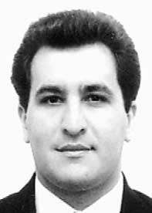
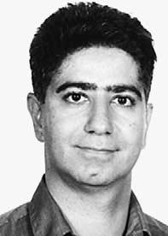

292

T. Korkmaz et al. / Computer Networks 46 (2004) 273–293

[7] C.-C. Chiang, H.-K. Wu, W. Liu, M. Gerla, Routing in
clustered multihop mobile wireless networks with fading
channel, in: The IEEE Singapore International Conference
on Networks (SICON), April 1997, pp. 197–211.
[8] R. Coltun, The OSPF opaque LSA option, Technical
Report RFC 2370, IETF, July 1998.
[9] D.E. Comer, Internetworking with TCP/IP, vol. 1, third
ed., Prentice-Hall, Englewood Cliﬀs, NJ, 1995.
[10] T.H. Cormen, C.E. Leiserson, R.L. Rivest, Introduction to
Algorithms, sixteenth ed., The MIT Press and McGraw-
Hill, Cambridge, MA, 1996.
[11] Y.K. Dalal, R.M. Metcalfe, Reverse path forwarding of
broadcast packets, Communications of the ACM21 (1978)
1040–1048.
[12] C. Diot, W. Dabbous, J. Crowcroft, Multipoint commu-
nication: a survey of protocols, functions, and mechanisms,
IEEE Journal on Selected Areas in Communications 15 (3)
(1997) 277–290.
[13] Z.J. Haas, M.R. Pearlman, The zone routing protocol
(ZRP) for ad-hoc networks, Technical report, Internet-
draft, IETF MANET Working Group, July 2002.
[14] P.A. Humblet, S.R. Soloway, Topology broadcast algo-
rithms, Computer Networks and ISDN Systems 16 (1989)
179–186.
[15] D.B. Johnson, D.A. Maltz, Y.-C. Hu, The dynamic source
routing protocol for mobile ad hoc networks, Technical
report, Internet-draft, IETF MANET Working Group,
February 2003.
[16] Y.-B. Ko, N.H. Vaidya, Location-aided routing (LAR) in
mobile ad hoc networks, in: Proceedings of the ACM/IEEE
MobiCom ’99 Conference, November 1998, pp. 66–75.
[17] V.O.K. Li, Z. Zhang, Internet multicast routing and
transport control protocols, Proceedings of the IEEE 90
(3) (2002) 360–391.
[18] J. Moy, OSPF version 2. Standards Track RFC 2328,
IETF, April 1998.
[19] J.T. Moy, OSPF: Anotomy of an Internet Routing
Protocol, Addison Wesley, Reading, MA, 1998.
[20] J.T. Moy, OSPF: Complete Implementation (with CD-
ROM), Addison Wesley, Reading, MA, 2000.
[21] S. Murthy, J.J. Garcia-Luna-Aceves, An eﬃcient routing
protocol for wireless networks, Mobile Networks and
Applications 1 (2) (1996) 183–197.
[22] S.-Y. Ni, Y.-C. Tseng, Y.-S. Chen, J.-P. Sheu, The
broadcast storm problem in a mobile ad hoc network, in:
Proceedings of the Fifth International Conference on
Mobile Computing and Networking (MobiCom’99), Au-
gust 1999, pp. 151–162.
[23] V. Park, S. Corson, Temporally-ordered routing algorithm
(tora) version 1 functional speciﬁcation, Technical Report,
Internet-draft, IETF MANET Working Group, February
2003.
[24] C.E. Perkins, E. Belding-Royer, S. Das, Ad hoc on-
demand distance vector routing, Technical Report, Net-
work Working Group, RFC 3561, July 2003.
[25] C.E. Perkins, P. Bhagwat, Highly dynamic destination-
sequenced distance-vector routing (dsdv) for mobile com-

puters, ACMSIGCOMMComputer Communication
Review 24 (4) (1994) 234–244.
[26] L.H. Sahasrabuddhe, B. Mukherjee, Multicast routing
algorithms and protocols: a tutorial, IEEE Network 14 (1)
(2000) 90–102.

Turgay Korkmaz received the B.Sc.
degree with the ﬁrst ranking from
Computer Science and Engineering at
Hacettepe University, Ankara, Tur-
key, in 1994, and two M.Sc. degrees
from Computer Engineering at Bil-
kent University, Ankara, and Com-
puter and Information Science at
Syracuse University, Syracuse, NY, in
1996 and 1997, respectively. He re-
ceived his Ph.D. degree from Electri-
cal and Computer Engineering at
University of Arizona, Tucson, AZ, in
December 2001. In January 2002, he
joined the University of Texas at San Antonio, where he is
currently an Assistant Professor of Computer Science
department. His research interests include QoS-based routing,
multiple constrained path selection, eﬃcient dissemination of
network-state information, topology aggregation in hierarchi-
cal networks, and performance evaluation of QoS-based
routing protocols. He is a Co-PI on the NSF High Perfor-
mance Network Connections (HPNC) Award to provide In-
ternet 2 Connectivity for UTHSCSA and UTSA. He was the
co-chair for the ACMSymposium on Applied Computing
(SAC 2003), Special Track on Parallel and Distributed Sys-
tems and Networking and the SAC 2004 Special Track on
Computer networks. He also served on the technical program
committee of IEEE INFOCOM2004.

Marwan Krunz is an associate profes-
sor of Electrical and Computer Engi-
neering at the University of Arizona.
His research interests lie in the ﬁeld of
computer networks, especially in its
performance and traﬃc control as-
pects. His recent work has focused on
the provisioning of quality of service
(QoS) over wireless links, QoS routing,
traﬃc modeling, bandwidth allocation,
video-on-demand systems, and power-
aware protocols for ad hoc networks.
He has published more than 70 journal
articles and refereed conference papers
in these areas. He is a recipient of the National Science Foun-
dation CAREER Award (1998–2002). He currently serves on
the editorial board for the IEEE/ACMTransactions on Net-
working and the Computer Communications Journal. He was a
Guest Co-editor for a Feature Topic on QoS Routing (IEEE
Communications, June 2001) and a Special Issue on Hot
Interconnects (IEEE Micro, January 2002). He is the Technical
Program Co-chair for the IEEE INFOCOM2004 Conference
(Hong Kong, March 7–11, 2004), and previously served as the
Technical Program Co-chair for the 9th Hot Interconnects
Symposium (Stanford University, August 2001). He has served
and continues to serve on the executive and technical pro-
gram committees of many international conferences. He serves
as a reviewer and a panelist for NSF proposals, and is a con-
sultant for several corporations in the telecommunications
industry.



T. Korkmaz et al. / Computer Networks 46 (2004) 273–293

Jyothi Guntaka received Bachelor of
Technology degree with a distinction
in Computer Science and Engineering
from Andhra University, Visakhapat-
nam, India. She received her M.S. in
Computer Science from The Univer-
sity of Texas at San Antonio, San
Antonio, Texas. Her research interests
include Quality of Service, Congestion
Control and Security in computer
networks.

293

